**Final Task Report**

**Date: -** 20/03/2023

**Task: -** Power Plant Data Study

**By: -** Tanuj Agarwal

**Data Assigned: -** 19/03/2023

**Assesment: -**

CO2 Emission and Temperature data of different power plants around the world is provided and we have to find some insights in this data. Data is provided according to the country, monthly, yearly, continent, city wise respectively.

**Deliverables: -**

* Data consist of coordinates of each power plant. We have to plot the points and show their location on the maps with different icons based on the type of power plant.
* Create a report of findings from the CO2 Emission and Temperature change due to a power plant.

From global_power_plant_database, I checked all types of primary fuel that is being used by the power plants around the world and there were total 14 types of primary fuel and some others primary fuels that are being used. I plotted a bar chart for the most used primary fuel and these were the results.

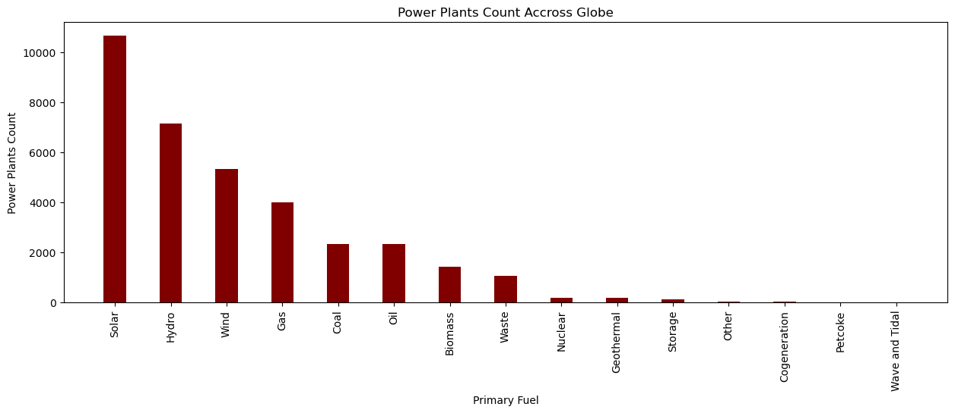

It is clear from the above graph that solar is most used primary fuel across globe. But this graph doesn’t give much information about different aspects related to it like CO2 emission and temperature change.

I worked on the other two files to look for some insight. Data was distributed according to city names and year wise so I aggregated the data according to the year so that same year data is available to me then I filtered the data again according to the country to get the unique countries data. This filtration resulted in data of 77 countries from year 1995-2019.

Now, I calculated the average temperature and average CO2 from 1995-2019 and plot a line chart.

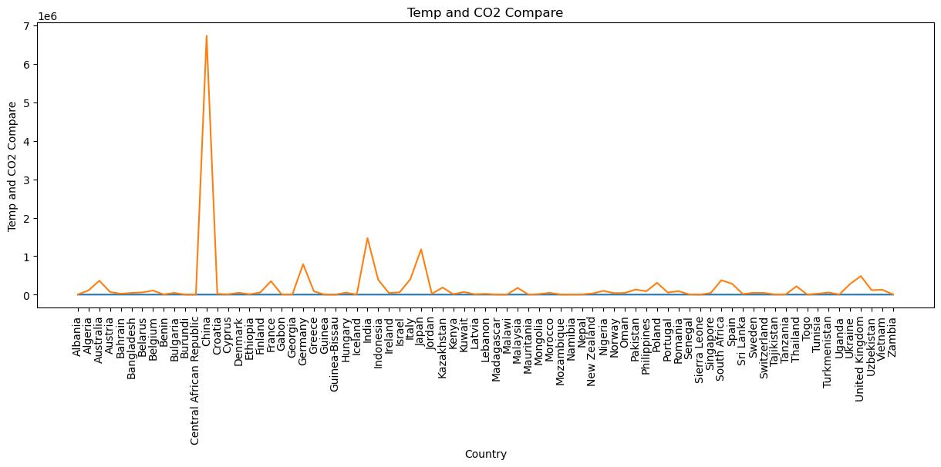

From the graph, it was clear that China’s CO2 was the highest among others and it was an outlier. If we remove China from the Dataset then there were two countries with higher CO2. The graph is below

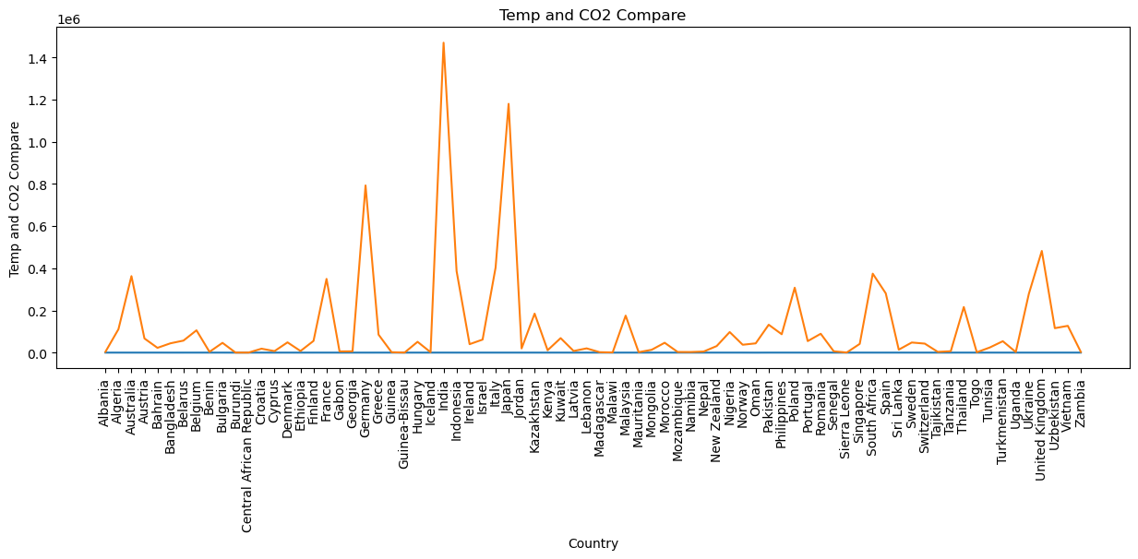

India and Japan were the next highest in terms of CO2 emission. So I first studied the number of plants, CO2 emission over the years and temperature change in China to understand the cause of this.